- OBJECTIVE
To establish the general guidelines for the protection and processing of personal data within the organization.
- SCOPE

Applies to all stakeholders of the organization and, in general, to all individuals whose personal data is processed by BPM Consulting SAS in the development of its corporate activities, regardless of the medium, format, or location in which such data is collected, stored, used, or processed.

- TERMS AND DEFINITIONS

Authorization
Prior, express, and informed consent of the Data Subject to carry out data processing.
Database
An organized set of personal data subject to processing.
Inquiry
A request made by the Data Subject or by persons authorized by the Data Subject or by law, to access the information stored about them in databases or files.
Personal Data
Any information that directly or indirectly refers to a natural person and allows their identification. Examples include name, identification number, home address, email address, phone number, and marital status.
Data Processor
A natural or legal person, public or private, who alone or jointly with others performs the processing of personal data on behalf of the Data Controller, and is subject to the obligations established in Law 1581 of 2012, its regulatory decrees, and instructions issued by the Superintendence of Industry and Commerce.
Data Controller
The natural or legal person responsible for deciding on the purposes and means of personal data processing, such as its use, circulation, or access.
Information Security
Preservation of confidentiality, integrity, and availability of information. Other properties such as authenticity, accountability, non-repudiation, and reliability may also be involved [NTC-ISO/IEC 27001].
Data Subject
A natural person whose personal data is subject to processing.
Processing
Any operation or set of operations performed on personal data, including but not limited to collection, storage, use, circulation, or deletion.

- I INFORMATION OF THE DATA CONTROLLER

BPM CONSULTING SAS, a legally incorporated commercial company, identified with NIT 900.011.395-6, with its main office in the city of Bogotá, is a Colombian company dedicated to providing outsourcing services for business process management and operations.
- Physical Address: Carrera 17 No. 164 – 25
- Contact Information: PQRSF option via website
- Website: https://www.bpmconsulting.com.co/
- Phone: (601) 7569094
BPM Consulting SAS acts as the Data Controller of personal data and is responsible for ensuring compliance with applicable data protection regulations.

- DATA SUBJECT AUTHORIZATION

Without prejudice to the exceptions provided in Law 1581 of 2012 and any other regulations that amend, add to, or complement it, the processing of personal data requires the prior and informed authorization of the Data Subject, which must be obtained through any means that can be subsequently consulted.

- EXCEPTIONS TO THE REQUIREMENT FOR PERSONAL DATA PROCESSING AUTHORIZATION

The Data Subject’s authorization shall not be required when it involves:
• Information requested by a public or administrative authority in the exercise of its legal functions or by court order.
• Data of a public nature.
• Medical or health emergency cases.
• Processing of information authorized by law for historical, statistical, or scientific purposes.
• Data related to the Civil Registry of Persons.

- R IGHTS OF DATA SUBJECTS

In accordance with the provisions established in Article 8 of Law 1581 of 2012, BPM CONSULTING SAS recognizes the following rights for Data Subjects:
- To know, update, and rectify their personal data held by BPM CONSULTING SAS. This right may be exercised, among others, in cases of partial, inaccurate, incomplete, fragmented data, data that induces error, or data whose processing is expressly prohibited or has not been authorized.
- To request proof of the authorization granted to BPM CONSULTING SAS, except when it is expressly exempted as a requirement for processing, in accordance with Article 10 of Law 1581 of 2012 and other regulations that modify, add to, or complement it.
- To be informed, upon request, by BPM CONSULTING SAS regarding the use that has been given to their personal data.
- To file complaints before the Superintendence of Industry and Commerce for violations of the provisions of Law 1581 of 2012 and other regulations that modify, add to, or complement it.
- To revoke authorization and/or request the deletion of data when the processing does not respect constitutional and legal principles, rights, and guarantees. Revocation and/or deletion will proceed when the Superintendence of Industry and Commerce has determined that BPM CONSULTING SAS has engaged in conduct contrary to the law and the Constitution.
- To access their personal data free of charge that has been subject to processing.

- DUTIES OF BPM CONSULTING SAS
- Guarantee to the Data Subject, at all times, the full and effective exercise of the habeas data right.
- Request and retain a copy of the respective authorization granted by the Data Subject.
- Properly inform the Data Subject about the purpose of data collection and the rights they are entitled to by virtue of the authorization granted.
- Store information under the necessary security conditions to prevent its alteration, loss, consultation, unauthorized use, or fraudulent access.
- Ensure that the information provided to the Data Processor is truthful, complete, accurate, updated, verifiable, and understandable.
- Update the information, promptly communicating to the Data Processor all changes regarding the data previously provided, and adopt all necessary measures to ensure that the information remains updated.
- Correct information when it is inaccurate and communicate the relevant updates to the Data Processor.
- Provide the Data Processor, as applicable, only with data whose processing has been previously authorized in accordance with Law 1581 of 2012 and other regulations that modify, add to, or complement it.
- Require the Data Processor at all times to respect the security and privacy conditions of the Data Subject’s information.
- Process inquiries and complaints submitted under the terms established in Law 1581 of 2012 and other applicable regulations.
- Adopt the necessary guidelines to ensure proper compliance with Law 1581 of 2012 and its complementary regulations, especially regarding the handling of inquiries and complaints.
- Inform the Data Processor when certain information is under dispute by the Data Subject, once a claim has been filed and the corresponding process has not yet been concluded.
- Inform the Data Subject, upon request, about the use given to their personal data.
- Report to the data protection authority any security breaches where there are risks in the management of Data Subjects’ information.
- Comply with instructions and requirements issued by the Superintendence of Industry and Commerce.

- SPECIFIC POLICIES FOR PERSONAL DATA PROTECTION

9.1 Processing of Personal Data of Employees, Interns, and Trainees
BPM Consulting SAS collects and processes the personal data of its employees, interns, candidates, and other trainees within the framework of the pre-contractual, contractual, and post-contractual stages, including, where applicable, sensitive data, in accordance with current regulations.
Personal data may be used for the management of recruitment processes, hiring, execution, and termination of the employment relationship; compliance with legal, contractual, and regulatory obligations; human talent administration; management of the Occupational Health and Safety System (SG-SST); response to requests from authorities; issuance of certifications; performance evaluation; disciplinary management; handling emergency situations; and the protection of the organization’s interests.
Likewise, the information may be used for administrative, financial, and accounting management; verification in restrictive lists and due diligence processes in compliance with SAGRILAFT and PTEE; handling of complaints, reports, and internal investigations; and the execution of welfare, training, diversity, equity, and inclusion activities, respecting principles of voluntariness and purpose limitation.
BPM Consulting SAS may process biometric data, images, and voice recordings when necessary for the development of its activities, in accordance with applicable regulations, with the corresponding authorizations, and under restricted use and information security criteria.
Information may be shared with clients, suppliers, partners, social security system entities, and other third parties when necessary for compliance with legal, contractual, or regulatory obligations, or for the proper execution of services, under confidentiality and security conditions.
Data will be processed during the duration of the relationship and subsequently for the time necessary to comply with legal, contractual, or legal defense obligations.

9.2 Processing of Personal Data of Contracting Clients
Commercial Relationship with State Entities
Within the framework of participation and execution of contracts derived from public procurement processes, including their different modalities and the instruments managed by the National Public Procurement Agency – Colombia Compra Eficiente, BPM Consulting SAS may process the personal contact data of public servants, supervisors, supervisory support staff, or other individuals designated by the contracting entity, to the extent necessary for the management of the pre-contractual, contractual, and post-contractual stages; operational coordination of the service; compliance with legal and contractual obligations; and the handling of requirements related to contract execution.
Commercial Relationship with Private Companies
The personal contact data of private sector clients may be processed by BPM Consulting SAS for the management of the pre-contractual, contractual, and post-contractual stages; the creation and administration of the client in the Company’s platforms or corporate tools; administrative, financial, and accounting management derived from the commercial relationship; compliance with legal, regulatory, tax, and contractual obligations; and, where applicable, the execution of due diligence processes for clients and beneficial owners in compliance with applicable SAGRILAFT and PTEE guidelines.
In both cases, the information will be processed during the term of the commercial or contractual relationship and subsequently for the time necessary to comply with legal, regulatory, contractual, or legal defense obligations.

9.3 End Users of Clients Receiving Services
BPM Consulting SAS generally acts as Data Processor with respect to the personal data of end users of the clients to whom it provides services. In this capacity, it processes information on behalf of the contracting client, in accordance with the instructions provided by the client, who retains the role of Data Controller and defines the purposes, scope of processing, and, where applicable, the mechanisms for informing and obtaining authorization from Data Subjects.
In the course of the services provided, and when defined by the client, BPM Consulting SAS will support its clients so that, through the established communication channels, Data Subjects are informed about the processing of their personal data in accordance with applicable regulations and the data processing policy defined by the respective contracting client.
When, during any interaction, the Data Subject expressly states their decision not to authorize the processing of their personal data or submits any related request, such situation will be recorded and forwarded to the contracting client, in its capacity as Data Controller, for handling in accordance with applicable regulations.
Within this same framework, when service execution involves campaigns, outbound contacts, surveys, information updates, or similar activities, BPM Consulting SAS will process the databases provided by the contracting client, who, as Data Controller, guarantees the legality of the processing and, where applicable, the obtaining of the necessary authorizations from Data Subjects.
Likewise, during service execution, BPM Consulting SAS may carry out contacts derived from prior interactions initiated by the Data Subject, when necessary for service continuity, handling of requests, or completion of processes within the scope of the contracted services.
In cases where the contracting client requires the processing of sensitive data, BPM Consulting SAS will act as Data Processor in accordance with the instructions provided, under the understanding that the Data Controller is responsible for defining the purpose, legality, and applicable conditions for such processing, as well as ensuring compliance with the corresponding legal requirements.
9.4 Processing of Personal Data of Suppliers
BPM Consulting SAS processes the personal data of its suppliers for the management of the commercial relationship, including selection processes, onboarding, evaluation, contractual execution, administrative, financial, and accounting management, compliance with legal and regulatory obligations, and due diligence processes in accordance with SAGRILAFT and PTEE.
The information will be processed during the contractual relationship and subsequently for the time necessary to comply with legal, contractual, or data retention obligations.

9.5 Processing of Personal Data of Visitors
BPM Consulting SAS processes the personal data of visitors for the purpose of managing access control, ensuring the security of its facilities and individuals, and complying with established security protocols.
For these purposes, the company may record entry logs and capture images through video surveillance systems (CCTV), in accordance with applicable regulations.
The information will be processed for the time necessary to fulfill the described purposes and to comply with the corresponding legal obligations.

9.6 Processing of Personal Data of Shareholders
The purposes for which shareholders’ personal data are used are:
a) To enable the exercise of the duties and rights derived from their condition as shareholders.
b) To comply with the regulations established in the Commercial Code and other applicable legislation.
c) To keep a record of the individuals who participate in ordinary and extraordinary meetings of the Company’s Shareholders’ Assembly, in their capacity as shareholder, secretary, president, or special guest.
d) To register their personal data in the Company’s shareholders’ registry book or minutes, when they hold the status of shareholders.
e) To carry out due diligence on the Data Subject in compliance with SAGRILAFT and PTEE, in accordance with the regulations of the Superintendence of Companies.
This information will be processed for the time necessary to comply with legal, corporate, and contractual obligations, in accordance with the legal or contractual circumstances that make the management of the information necessary.

9.7 Processing of Personal Data from the Website and Social Media
Personal data collected through the website and social media channels will be used for the management and response to petitions, complaints, claims, reports, and other requests.
In the case of recruitment processes, the information will be managed by the Human Talent area in accordance with the provisions established in section 9.1.
The information will be processed for the time necessary to manage the request and subsequently for compliance with legal obligations or data retention requirements.

- MINORS’ DATA

De acuerdo con el Artículo 7 de la Ley 1581 de 2012, BPM CONSULTING SAS manifiesta In accordance with Article 7 of Law 1581 of 2012, BPM CONSULTING SAS states that the personal data of children and adolescents are used exclusively for the following purposes:
- Social Security and Parafiscal Affiliations: The Company collects and processes the personal data of its employees’ minor children solely for the purpose of complying with legal obligations imposed on employers regarding affiliation to the social security and parafiscal systems.
- Welfare Programs: For beneficiary children of our employees. Authorization for the use of this personal data is granted by the parents or legal guardians of the minor, who will be explicitly and previously informed about the data subject to processing, its purpose, and the optional nature of answering questions regarding the data of children and adolescents.
BPM CONSULTING SAS will ensure that the processing of this type of data is carried out in accordance with the rights of children and adolescents. In this regard, their special status will be protected, and respect for their fundamental rights will be guaranteed.

- SENSITIVE DATA

BPM Consulting SAS podrá tratar datos sensibles cuando sea necesario para el desarrollo de sus actividades, conforme a la normativa vigente y garantizando su uso restringido, confidencialidad y las autorizaciones correspondientes.

In particular:
- Health data: for the management of the Occupational Health and Safety System (SG-SST).
- Diversity data: provided on a voluntary basis, within the framework of inclusion and well-being programs.
- Biometric data, images, and voice recordings: used for security purposes, access control, identification, and institutional use, in accordance with applicable regulations and under restricted use criteria.
The Data Subject may choose not to provide sensitive data, except in cases where there is a legal obligation to do so.

- INQUIRY, COMPLAINT, AND CLAIM HANDLING CHANNEL

BPM CONSULTING SAS has established the following channel for handling requests, inquiries, and claims, through which the Data Subject, their representative, and/or authorized agent may exercise their rights to know, update, rectify, delete, or revoke their authorization:
- Physical Address: Carrera 17 No. 164 – 25
- Contact Information: PQRSF option via website
- Website: https://www.bpmconsulting.com.co/
- Phone: (601) 7569094

- PROCEDURE FOR HANDLING INQUIRIES, CLAIMS, PETITIONS, AND MECHANISMS TO EXERCISE DATA SUBJECT RIGHTS

Once BPM CONSULTING SAS has received the request, inquiry, or claim from the Data Subject through the established service channels, it will proceed and respond as follows:
Inquiry:
The inquiry will be addressed within a maximum term of ten (10) business days counted from the date of receipt. If it is not possible to respond within this period, the interested party will be informed of the reasons for the delay, indicating the date on which the inquiry will be addressed. In any case, this additional term may not exceed five (5) business days following the expiration of the initial period.
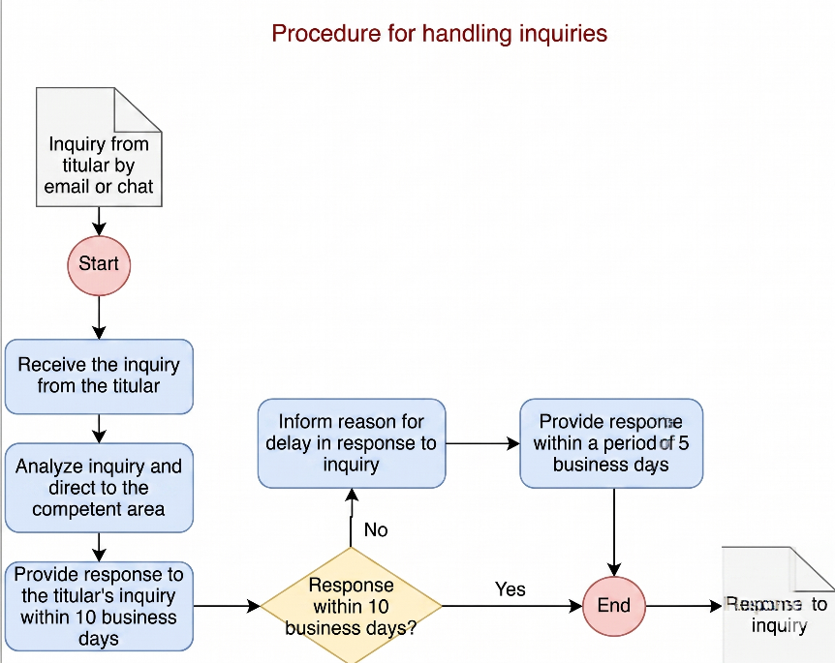

Claims :
The Data Subject who considers that the information contained in a database should be corrected, updated, or deleted, or who notices a presumed breach of any of the duties established in this policy, may submit a claim to BPM CONSULTING SAS, which will be processed as follows:
The claim must be submitted in writing to BPM CONSULTING SAS and must include: the identification of the Data Subject, a description of the facts giving rise to the claim, contact information (address), and any supporting documents that are intended to be relied upon.
If the claim is incomplete, the Data Subject will be required within five (5) days following receipt of the claim to correct the deficiencies. If, within two (2) months from the date of the request, the applicant fails to provide the required information, it will be understood that the claim has been withdrawn.
If the recipient of the claim is not competent to resolve it, the claim will be forwarded to the appropriate party within a maximum of two (2) business days, and the Data Subject will be informed of this situation.
Once a complete claim has been received, it shall be addressed within no more than fifteen (15) business days counted from the day following its receipt. If it is not possible to respond within this period, the Data Subject will be informed of the reasons for the delay and the date on which the claim will be resolved, which in no case may exceed eight (8) business days following the expiration of the initial term.
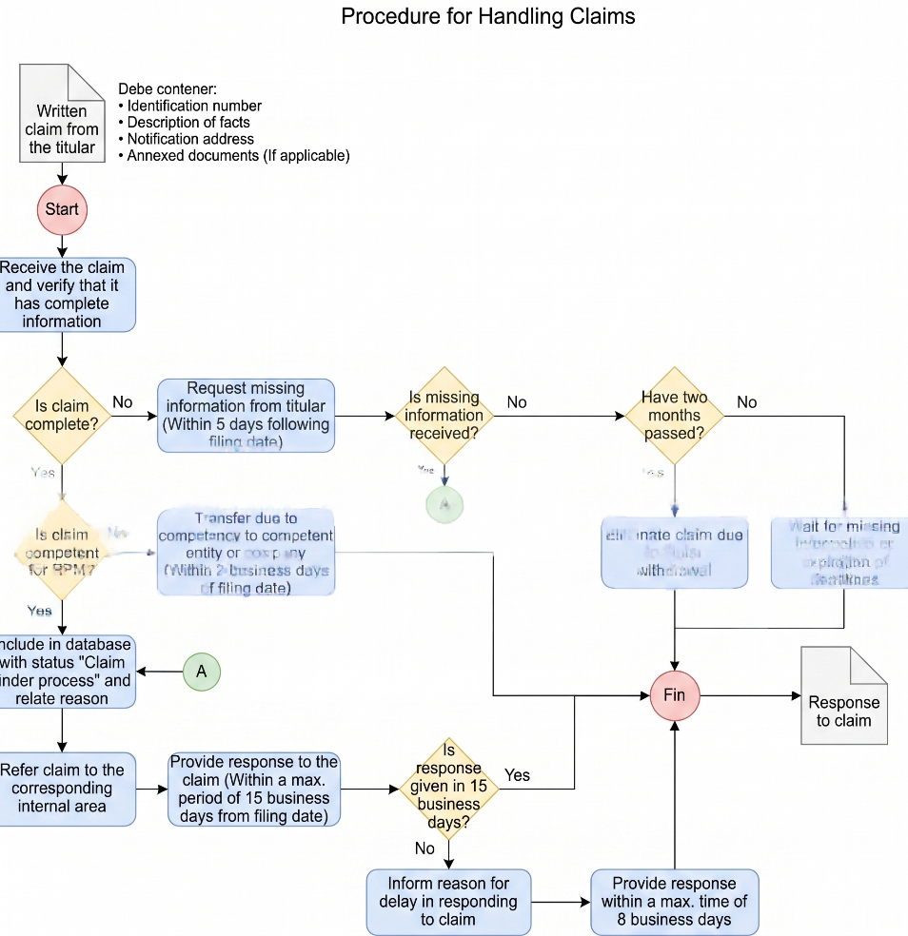

13.1 Minimum Content of the Request
Requests submitted by the Data Subject for the purpose of making an inquiry or filing a claim regarding the use and handling of their personal data must contain specific information that allows for a proper analysis of the request and an appropriate response.
The communication must meet the following requirements:
- Be addressed to BPM CONSULTING SAS.
- Include the identification of the Data Subject (full name and identification document).
- Provide the physical and/or electronic address (e-mail) for notifications.
- Contain a description of the facts giving rise to the inquiry or claim.
- Indicate the purpose of the request (rectification, update, deletion, or revocation of authorization).
- Attach any documents considered relevant to support the inquiry and/or claim.
In the event that the inquiry or claim is submitted in person, the Data Subject must present it in writing without any additional formality other than the requirements stated above.

13.2 Procedural Requirement
The Data Subject of personal data may file a claim before the Superintendence of Industry and Commerce (SIC) once they have exhausted the internal procedure before BPM CONSULTING SAS, acting as both Data Controller and Data Processor of personal data.
a. Revocation of Authorization
The Data Subject may revoke at any time the consent or authorization granted for the processing of their personal data, provided that there is no legal or contractual impediment that prevents such revocation.
b. Data Deletion (Erasure)
The Data Subject has the right to request at any time that BPM CONSULTING SAS delete or remove their personal data in the following cases:
- When they consider that the data is not being processed in compliance with the principles, duties, and obligations set forth in applicable regulations.
- When the data is no longer necessary or relevant for the purpose for which it was collected.
- When the time required to fulfill the purposes for which the data was collected has expired.
Such deletion implies the total or partial removal of personal information, as requested by the Data Subject, from records, files, databases, or processing activities carried out by BPM CONSULTING SAS.
The right to cancellation is not absolute; therefore, BPM CONSULTING SAS may deny the revocation of authorization or deletion of personal data in the following cases:
- When the Data Subject has a legal or contractual obligation to remain in the database.
- When deletion of the data would hinder judicial or administrative proceedings related to tax obligations, the investigation and prosecution of crimes, or the enforcement of administrative sanctions.
- When the data is necessary to protect legally protected interests of the Data Subject, to perform actions in the public interest, or to comply with a legal obligation assumed by the Data Subject.

- INFORMATION SECURITY IN THE PROTECTION OF PERSONAL DATA

BPM Consulting SAS has implemented technical, human, and administrative measures to protect personal data, in accordance with its Information Security Management System.

The organization may rely on third parties for the processing of personal data when necessary for the execution of its activities, ensuring that such third parties comply with confidentiality obligations, information security requirements, and personal data protection standards in accordance with applicable regulations.

- DATA RETENTION PERIOD

DATA RETENTION
BPM CONSULTING SAS will retain personal data in its systems in accordance with the following retention criteria:
General Criterion: For the time necessary to fulfill the purpose for which the data processing was initially intended.
Legal Criterion: For the periods established under special regulations (10 years for accounting records; 20 years for Occupational Health and Safety records; and indefinitely for employment records/history files).
Security Criterion: Video surveillance and access control data will be retained for a maximum period of 15 days, unless they are required as evidence in disciplinary, administrative, or judicial proceedings.
Selection Criterion: Resumes of non-selected candidates will be retained for a period not exceeding one (1) year, after which they will be securely deleted.
Once these periods have expired, or the purpose that justified the processing no longer exists, BPM CONSULTING SAS will proceed with the deletion or anonymization of the data, ensuring that the information can no longer be associated with the Data Subject.
.

- INTERNATIONAL TRANSFER AND TRANSMISSION OF PERSONAL DATA

BPM Consulting SAS may carry out the transmission or transfer of personal data to third parties located within or outside the national territory when necessary for the development of its activities, the execution of contracts, or the provision of its services.

In such cases, the organization will adopt reasonable measures to ensure that these transfers are carried out in compliance with applicable personal data protection regulations and will require third parties to comply with confidentiality obligations, information security requirements, and personal data protection standards appropriate to the nature of the processing.
.

- POLICY VALIDITY

The policy established by BPM CONSULTING SAS regarding the processing of personal data may be modified at any time. Any modification will be made in accordance with applicable legal regulations and will become effective upon its publication through the Company’s internal communication channels and on its official website, so that Data Subjects are informed about the data processing policy and any changes made to it.

- COMPLIANCE

The Senior Management of BPM CONSULTING SAS is committed to fulfilling its duties and responsibilities before the Colombian State in relation to all applicable regulations. Accordingly, the organization will ensure strict compliance with personal data protection regulations.

- TRACEABILITY

VERSIÓN | APPROVAL DATE | CHANGES CONTROL
5 | 4/05/2022 | The contact channels for requests, inquiries, and applications submitted by Data Subjects have been updated.
6 | 07/12/2023 | - Comprehensive review of the document.  - Standardization of the organization’s name.  - Formatting adjustments throughout the document.  - Inclusion of the statement “Information required by a public or administrative entity in the exercise of its legal functions or by judicial order” in section 3 EXCEPTIONS FOR AUTHORIZATION OF PERSONAL DATA USE, in accordance with the provisions of Article 10 of Law 1581 of 2012.  - Update of the positions responsible for preparing and reviewing the document.
7 | 08/01/2014 | - Inclusion of the following chapters:  • Personal Data Retention Period  • Duties of BPM Consulting SAS  - Inclusion of the item “Access to main headquarters and/or rented facilities” in the Purposes section.  - Expansion of the content in the “Reports/Denunciations” section.
8 | 02/04/2024 | - Inclusion of the due diligence process in the selection procedures for employees and suppliers.  - Inclusion in the “Purposes” section of relevant provisions regarding end users of clients receiving Contact Center and BPO services.  - Inclusión de nota aclaratoria para los servicios FEEL.
9 | 05/09/2024 | - Full update of the document content.
10 | 13/11/2024 | - Update of Chapter 9 “Sensitive Data” to include Resolution 700 of October 13, 2023, and any regulations that amend or replace it.  - This adjustment is made because said Resolution identifies, in its “Considerations” section, differential population groups that BPM Consulting may at some point interact with and for which personal data processing may occur.
11 | 23/02/2026 | - Update of the corporate image through the incorporation of the new logo and the adjustment of colors in tables and text, aligned with the new institutional color palette.
12 | 24/03/2026 | - Comprehensive update of the Personal Data Processing Policy to strengthen its alignment with current personal data protection regulations.  - Adjustment of Chapter 9 sections related to employees, contracting clients, and users, incorporating clearer definitions of roles (Data Controller and Data Processor), processing purposes, and consistency with processing agreements signed with clients.  - Integration of interns and trainees within the employee category, eliminating their treatment as a separate category.  - Inclusion of guidelines related to the processing of biometric data, images, voice recordings, and the use of technological tools, ensuring compliance with applicable regulations and corresponding authorizations.  - Adjustment of the sections related to suppliers, visitors, shareholders, and digital channels, improving consistency in processing purposes and data retention criteria.  - Update of the sensitive data section, incorporating processing under criteria of necessity, legality, and restricted use.  - Adjustment of the information security section, including the use of third parties in personal data processing under confidentiality and security conditions.  - Inclusion of the following chapters: International transfer and transmission of personal data; Database retention period.  - Standardization of data retention criteria in accordance with legal, contractual, and data preservation obligations.  - Removal of operational content and strengthening of the policy-oriented approach, ensuring consistency, clarity, and organizational applicability.

